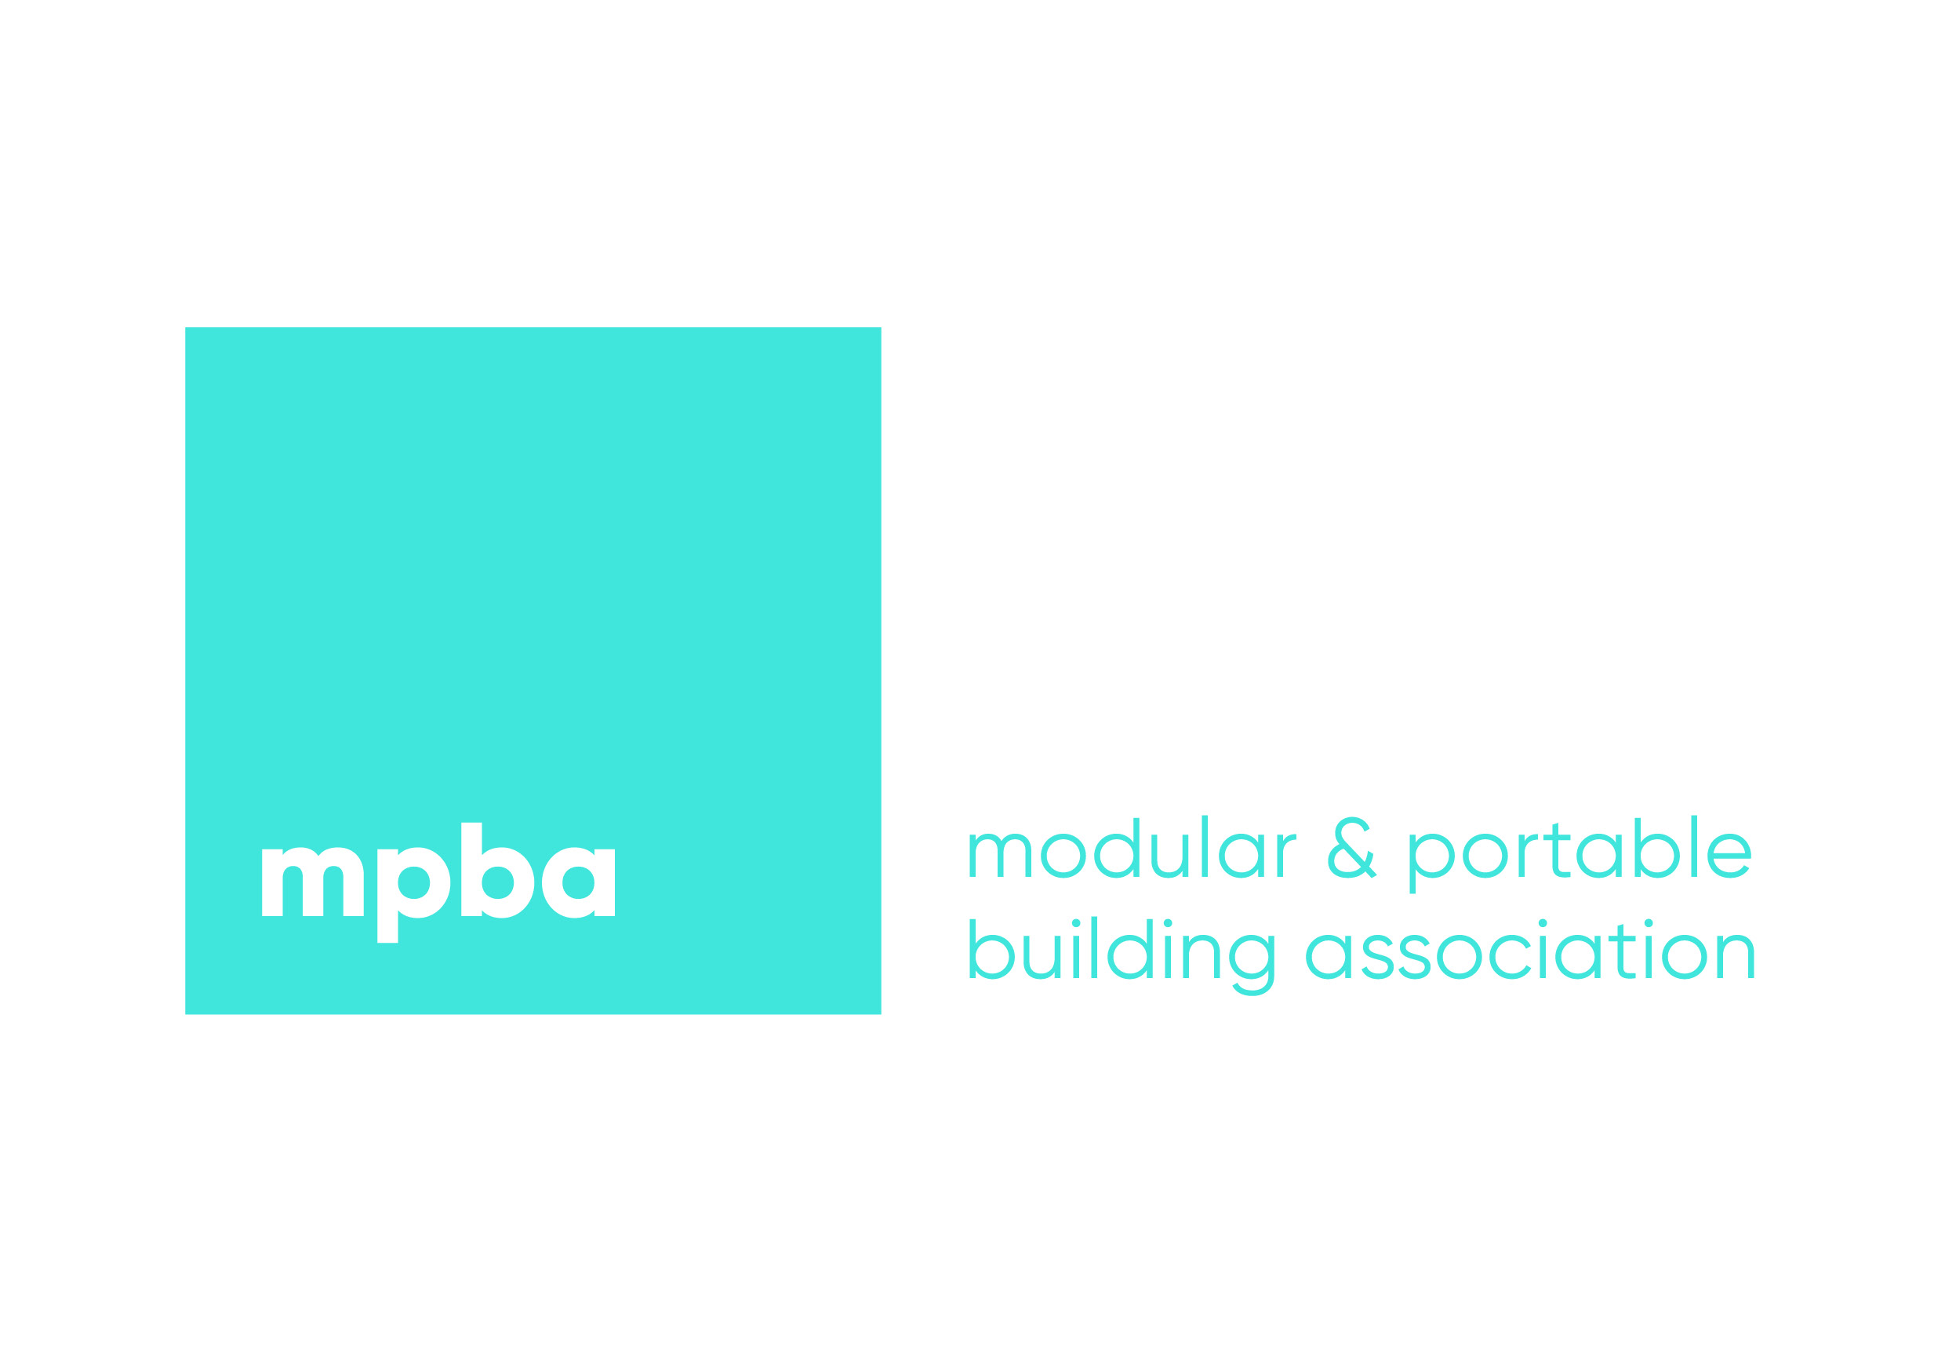

MPBA 2022 GOLF DAY & EVENING DINNER

THURSDAY 23rd June 2022

Belton Woods Golf Course

Gonerby Grange Lane,
Belton
Grantham
NG32 2LN

Golf, Dinner & Accommodation/Breakfast

£220.00

Non- Golfer –Dinner & Accommodation/Breakfast

£165.00

(Prices are exclusive of vat which will be charged at the standard rate of 20%)
(Prices are based on single room occupancy)

Invoices will be raised on receipt of booking form being received – payment is required by return to secure places.

