Modular and Portable Building Association National Conference 2025

22nd May 2025

National Memorial Arboretum, Burton-On-Trent, DE13 7AR

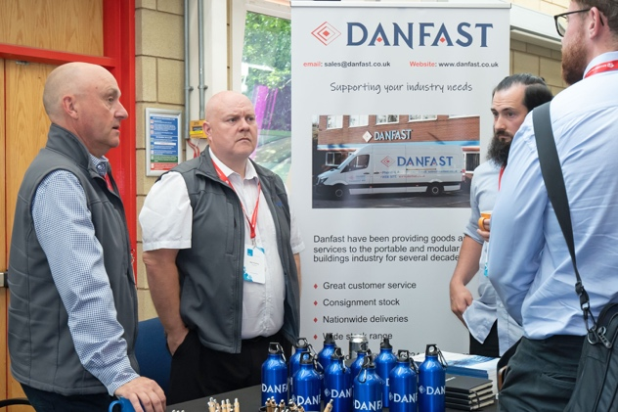
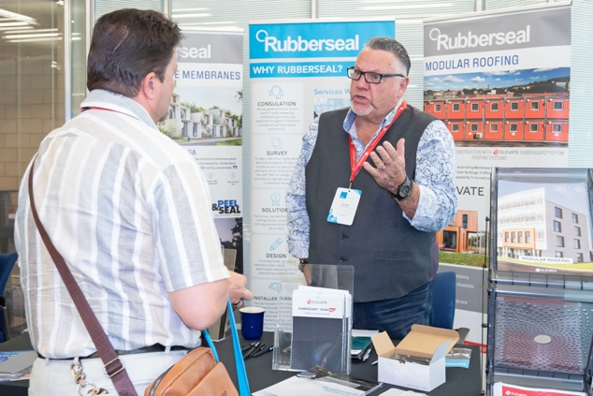
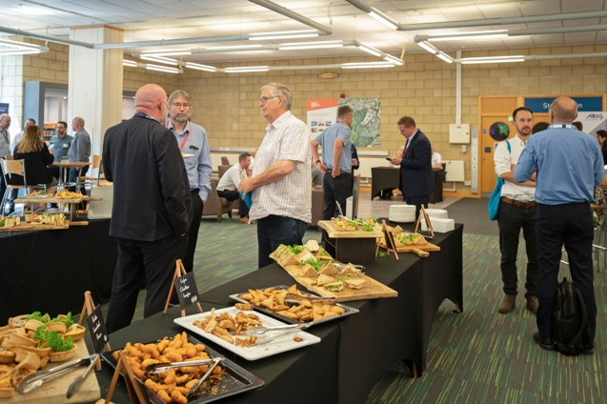
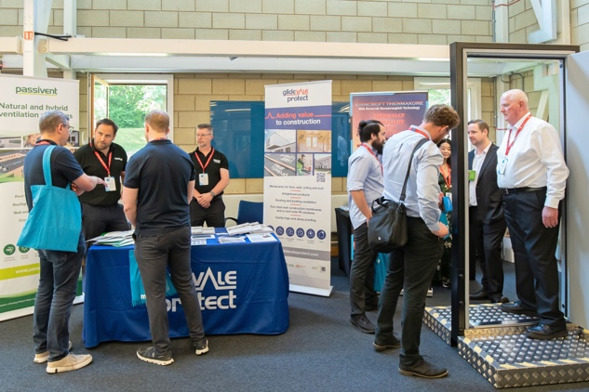
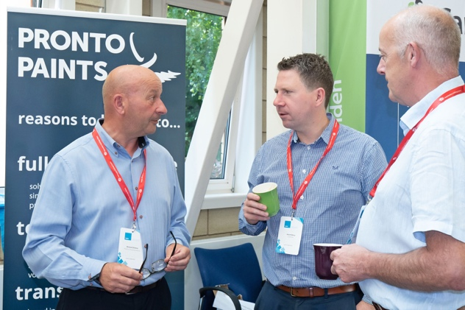
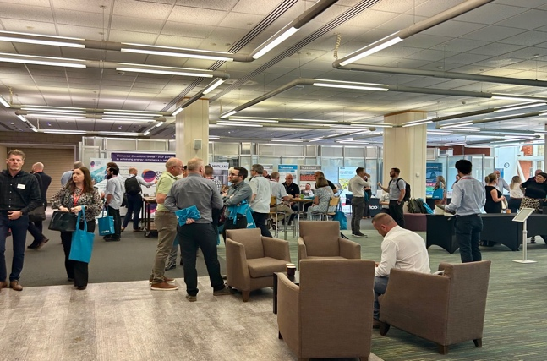

Photos from National Conference 2024

Welcome to our third National Conference, taking place on the 22nd of May 2025 at the National Memorial Arboretum, Croxall Road, Burton-on-Trent, Staffordshire.
The Conference offers an opportunity to reach members with details of your products and services. The conference is positioned to attract 150-200 individuals from our full members across various disciplines.

It’s an important event for all our full members to attend, to not only keep up to date with what is impacting our industry today, but what to expect for the future. We have confirmed speakers from Government and Associated Bodies to provide updates and field questions relating to the future of modular and portable buildings for new construction, refurbishment, and hire.

Topics cover technical, health and safety and sustainability, so we encourage different disciplines to attend where relevant.
There are two options for Associate Members to get involved:

Option one:

- Take a stand in our Networking area. The Networking area will be the area used for registration, drinks, and lunch, providing an excellent opportunity to showcase products and network with current and potential new clients from our full membership.

  - Package includes.
    - Tabletop stand space, approx. 3m x 1m.
    - Single plug socket.
    - Entry for two staff, including drinks and lunch.

  - £350 + VAT

Option Two:

- Headline sponsorship, inclusive of stand space within the Networking area as above, with the addition of the following:

    - Your branding featured on all conference marketing before, during and post show.
    - You’re branding on all conference slides and backgrounds, personal thank you from a session chair, providing a brief description of your products to attendees.
    - Literature on reception desk and/or conference seating.
    - Entry for a total of three staff including drinks, lunch, and conference access.

  - £1,200 + VAT

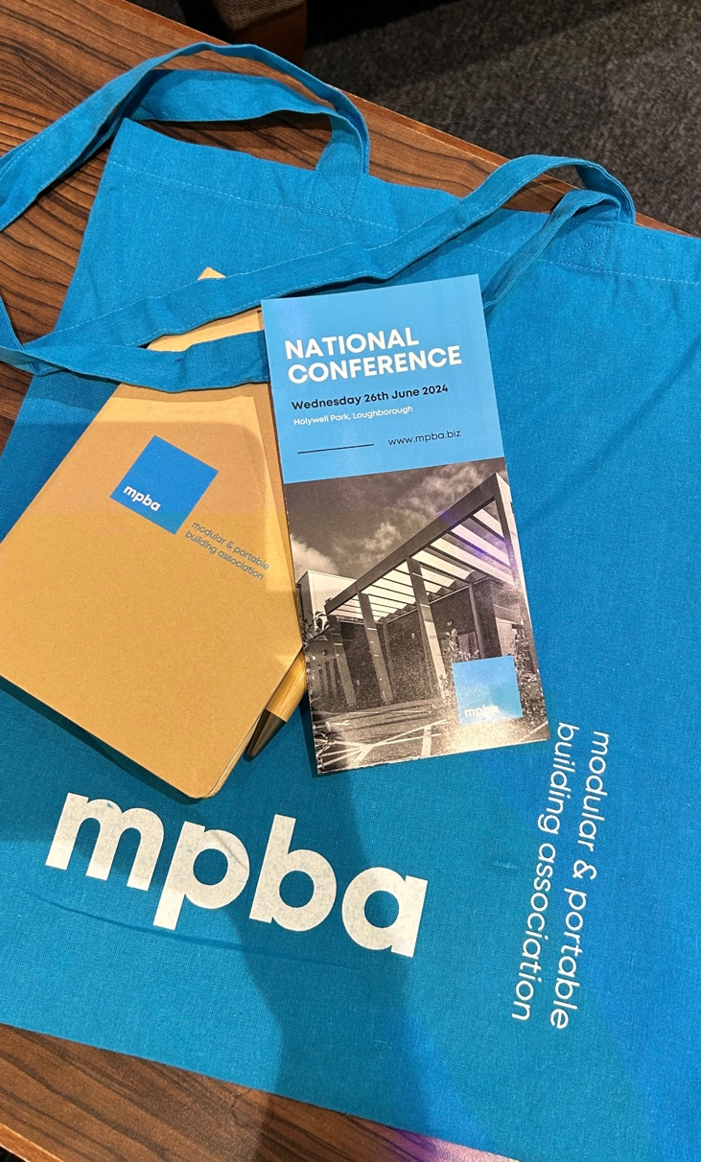

Modular and Portable Building Association National Conference 2025

22nd May 2025

National Memorial Arboretum, Burton-On-Trent, DE13 7AR

Associate Member Booking Form

Company Name: [ ]
Main Contact Name: [ ]
Main Contact email: [ ]
Main Contact Phone: [ ]

Please accept this form as confirmation of booking for the following option(s):

Headline sponsorship (and stand space)

Stand space only.

I understand in returning this form, I acknowledge to be invoiced by the MPBA for the relevant amount and commit to payment within 30 days.

Purchase Order Number: [ ] (if required for invoice)

Signed:

Name: [ ]

Date: [ ]

Please circle preferred invoice date from options below:

ASAP 31/01/2025 01/03/2025 31/04/2025

Note: Spaces are limited and will be made available on a first come, first served basis

Please return form to richard@mpba.biz

