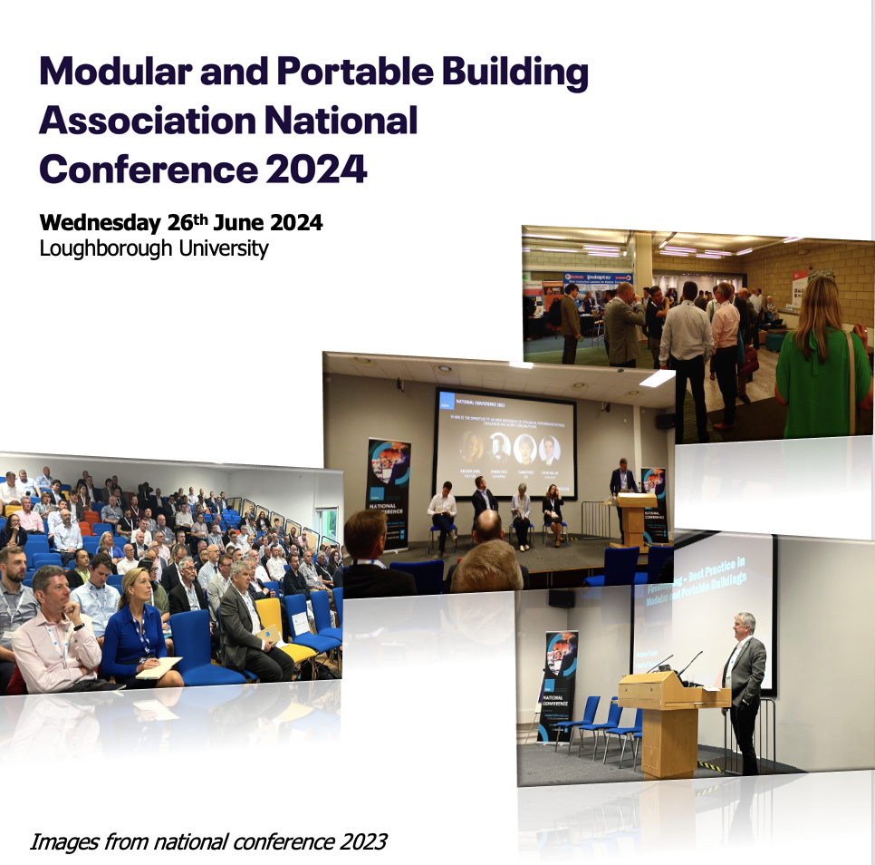

Associate Member Sponsorship Opportunities

The Conference offers a new opportunity to reach members with details of your products and services. The conference is positioned to attract 150-200 individuals from our full members across various disciplines.

There are two options for getting involved:

- Take a stand in the Babbage networking area. The Babbage will be the area used for registration, drinks, and lunch, providing an excellent opportunity to showcase products and network with current and potential new clients from our full membership.

  - Package includes
    - Tabletop stand space, approx. 3m x 1m
    - Single plug socket
    - Entry for two staff, including drinks and lunch

  - £350 + VAT

- Headline sponsorship, inclusive of stand space within the Babbage networking area as above, with the addition of the following:

    - Your branding featured on all conference marketing before, during and post show.
    - You branding on all conference slides and backgrounds, personal thank you from a session chair, providing a brief description of your offer to attendees.
    - Literature on reception desk and/or conference seating.
    - Entry for a total of three staff including drinks, lunch and conference access.

  - £1,200 + VAT

Modular and Portable Building Association National Conference 2023

Wednesday 26th June 2024
Holywell Park Conference Centre, Loughborough, LE11 3GR

Associate Booking Form

Company Name: [ ]
Main Contact Name: [ ]
Main Contact email: [ ]
Main Contact Phone: [ ]

Please accept this form as confirmation of booking for the following option(s):

Headline sponsorship (inc stand space)
Stand space only

I understand in returning this form, I acknowledge to be invoiced by the MPBA for the relevant amount and commit to payment within 30 days.

Purchase Order Number: [ ] (if required for invoice)

Signed:

Name: [ ]

Date: [ ]

Please circle preffered invoice date from options.

ASAP 31/01/2024 01/03/2024 31/04/2024

Note: Spaces are limited and will be made available on a first come first served basis

Please return form to richard@mpba.biz

