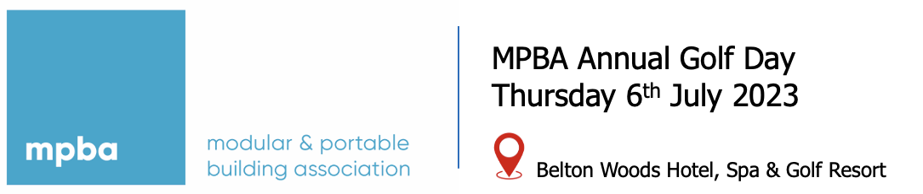

Please return completed form to Jackie Maginnis at jackie@mpba.biz by 31st March 2023

Golf, Dinner, Accommodation & Breakfast (single occupancy) £255 + VAT
Golf, Dinner, Accommodation & Breakfast (Double occupancy – 2 golfers) £360 + VAT
Non-Golfer, Dinner, Accommodation & Breakfast £185 + VAT

Company Name
Company Address
Contact Telephone
Contact Email
Players details:

Name
Golf & Dinner
Dinner ONLY
Accommodation
Handicap

Name
Golf & Dinner
Dinner ONLY
Accommodation
Handicap

Name
Golf & Dinner
Dinner ONLY
Accommodation
Handicap

Name
Golf & Dinner
Dinner ONLY
Accommodation
Handicap

