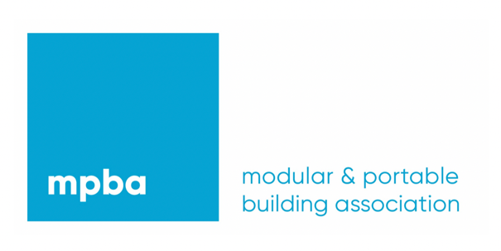

General Meeting

&

Annual Dinner

8th December 2022

The Arden Hotel & Leisure Club
Coventry Road
Bickenhill
Solihull
B92 0EH

Meeting starts at 2.30pm
(Refreshments available from 2.00pm)

Christmas Dinner starts at 7.00pm

Entertainment

Table Magician & Casino Tables

Sponsored by



